Outdoor Entertaining with The Pot Company

We’re very proud to offer a wide range of burners and wood storage to complete the look of your outdoor space. Hand crafted in Europe the selection includes fire bowls, tables, outdoor fire places and wood storage. Regardless of the space you have available or the budget you’re trying to work to it’s never been so easy to keep your garden feeling warm and looking great! All our burners are available in high quality corten steel which comes to us as a blue steel but as soon as it is exposed to the elements weathers to develop a rich rust finish.
Below we’ve picked out our five favourites from the Burner Range.
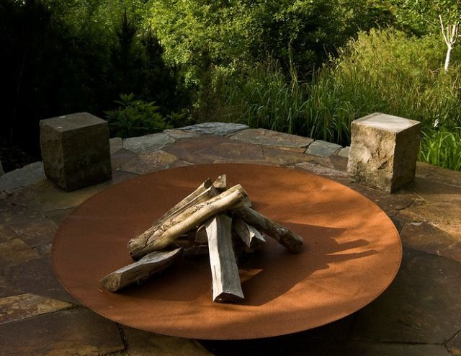
Fire pit
Made from 3mm thick corten steel, these bowls are one of our best selling products. The burners are easy to move around, come with a circular stand welded to the base and holes in the base for maximum airflow. Overall this is an extremely strong, attractive low maintenance garden feature.

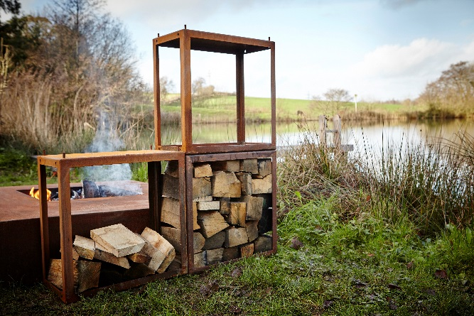
Linkable cubes
These cubes are designed to be stacked so you can buy just one or multiple units. Made from 2mm thick corten steel, they are ideal for quickly and naturally drying and seasoning your logs whilst creating a beautiful feature for your garden.

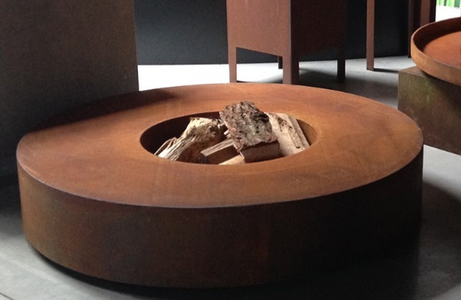
Fire Table
Our striking fire tables are made from 3mm thick corten steel and are perfect for outdoor entertaining. The stunning contemporary look will add character to any setting. The tables are offered in a variety of sizes in either round or square. Its lightweight hollow construction gives it a strong appearance but gives you the freedom to change its location.

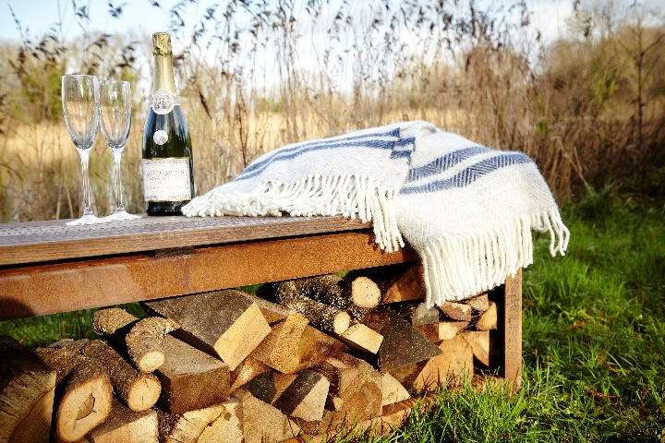
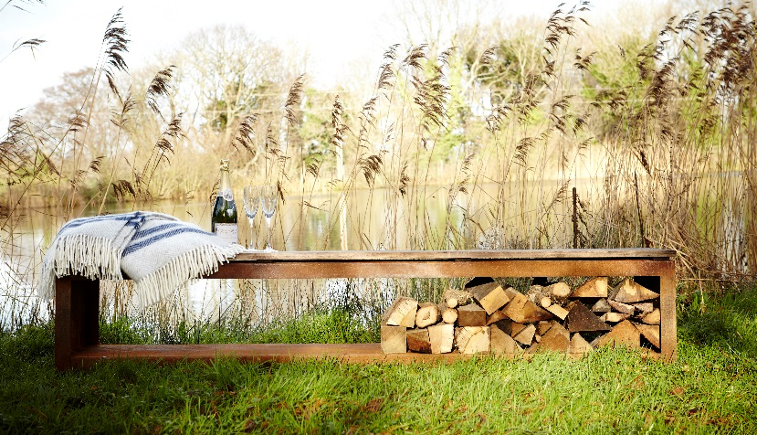
Storage Bench

You’ve added a burner to your garden now you need somewhere to enjoy it from! Our beautiful wood storage bench allows you to create a feature in your garden that is also highly functional. Available in either corten steel or jet black heat resistant paint this item is the perfect addition to any of the burners we offer!

Enok
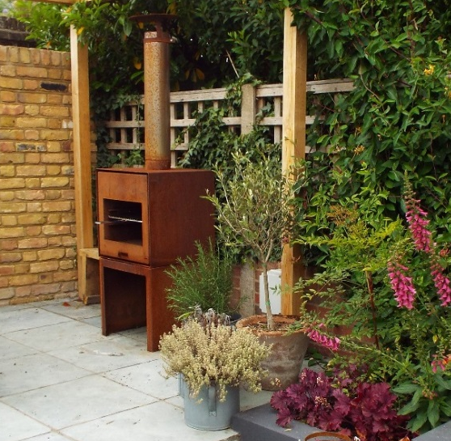
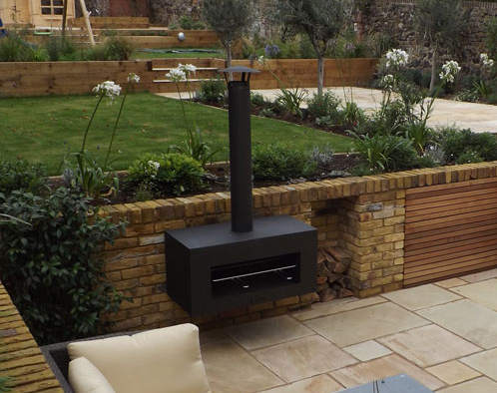

Our Enok burner creates a focal point in your garden and is an extremely versatile product. Customers have the choice of corten steel or black and are then able to choose from an elegant standing, unique hanging or space saving wall hung burner. With optional accessories such as BBQ grill, flues and rain caps.

This is just a small selection of what we have on offer!
To see more visit www.thepotco.com. If you have any questions our friendly sales team will be more than happy to guide you through the options. Contact us on 01892 890 353 or sales@thepotco.com.

